BACHELOR OF SCIENCE
(COMPUTER APPLICATION & INFORMATION TECHNOLOGY)



SUBMITTED TO
Department Of Computer Science
KSKV Kutch University, Bhuj
SUBMITTED BY
Ummehani MohamadArif Khatri
Enroll No: 2023001010
IGI-3 : Third Person Shooter Game Using Unity

MAJOR PROJECT REPORT

ABSTRACT

IGI-3 is a 3D Third Person Shooter (TPS) game developed using Unity and C#. The aim of the project is to design and implement a mission-based action game that demonstrates player control, artificial intelligence, shooting mechanics, UI design, animation, and complete game flow.
The player controls a soldier in a guarded environment and must eliminate all enemies to complete the mission. The game integrates enemy AI with patrol, detection and shooting behaviours. A health system, reload system, enemy counter, main menu, game over and win screens are implemented to provide a complete gameplay experience.
This project demonstrates the complete game development lifecycle including requirement analysis, design, implementation, testing and evaluation.

ACKNOWLEDGEMENT

I would like to express my sincere gratitude to my respected project guide for their continuous guidance, encouragement and valuable suggestions throughout the development of this project titled “IGI-3: Third Person Shooter Game Using Unity.” Their constant support, technical advice and motivation played a vital role in the successful completion of this work.
I am also thankful to the Head of the Department and the faculty members of the Department of Computer Engineering for providing the necessary facilities, resources and learning environment required to carry out this project successfully.
I would like to extend my heartfelt thanks to my friends and classmates for their cooperation, constructive feedback and encouragement during the development and testing phases of the project.
Finally, I express my deepest gratitude to my family for their unconditional support, patience and motivation throughout my academic journey. Their encouragement has always inspired me to complete this project successfully.
I am truly grateful to everyone who directly or indirectly contributed to the completion of this project.

Contents

CHAPTER 1 : 3
1.1 Background of the Project
1.2 Introduction to Third Person Shooter Games
1.3 Aim of the Project
1.4 Objectives of the Project
1.5 Scope of the Project
1.6 Problem Statement
1.7 Proposed Solution
1.8 Methodology Overview
CHAPTER 2 : 6
2.1 Introduction
2.2 Feasibility Study
2.3 Functional Requirements
2.4 Non-Functional Requirements
2.5 Development Model
CHAPTER 3 : 9
3.1 Introduction
3.2 Overall Architecture of the Game
3.3 Module Design
3.4 Data Flow Explanation
3.5 Summary
CHAPTER 4 : 16
4.1 Introduction
4.2 Development Environment
4.3 Scene Creation & Environment Setup
4.4 Player Implementation
4.5 Shooting & Reload Implementation
4.6 Enemy AI Implementation
4.7 Health System Implementation
4.8 UI Implementation
4.9 Game Flow Implementation
4.10 Testing Strategy
4.11 Summary
CHAPTER 5 : 23
5.1 Introduction
5.2 Final Game Overview
5.3 Gameplay Demonstration
5.4 Results Summary Table
5.5 Discussion
5.6 Advantages of the System
CHAPTER 6 : 28
6.1 Conclusion
6.2 Learning Outcomes
6.3 Limitations of the Project
6.4 Future Scope
6.5 Final Summary

REFERENCES

CHAPTER 1 :
INTRODUCTION

1.1 Background of the Project
The gaming industry has grown rapidly in recent years due to advancements in computer graphics, game engines, and artificial intelligence. Modern video games require integration of multiple technologies such as physics simulation, AI, animation, user interface design, and software engineering principles.
Game development provides an excellent platform to apply programming knowledge in a practical and interactive way. Among different game genres, Third Person Shooter (TPS) games are highly popular because they combine action, strategy, and immersive gameplay.
This project focuses on developing a TPS game named IGI-3 using the Unity game engine. The project demonstrates the design and development of a complete playable game from scratch using C# programming.

1.2 Introduction to Third Person Shooter Games
A Third Person Shooter game is a genre in which the player controls a character from a third-person perspective, typically from behind the character. Unlike First Person Shooter games, TPS games allow the player to see the character’s body and surroundings, providing better spatial awareness and tactical gameplay.
Examples of TPS games include:
• Mission-based combat games
• Survival shooter games
• Action adventure games
TPS games usually include the following components:
• Player movement and camera control
• Shooting and combat system
• Enemy AI behaviour
• Health and damage system
• Mission objectives and UI
The IGI-3 project implements all these features.
1.3 Aim of the Project
The main aim of this project is to design and develop a fully functional 3D TPS game using Unity and C# that demonstrates real-world game development workflow and programming concepts.

1.4 Objectives of the Project
The major objectives of this project are:
Primary Objectives
• To design a third-person player controller
• To implement enemy AI with patrol and attack behaviour
• To create a shooting and reload system
• To implement player health and damage system
• To design a user interface for gameplay
• To implement game flow including menu and game over screens

Secondary Objectives
• To understand Unity game engine workflow
• To apply object-oriented programming concepts
• To learn game physics and collision detection
• To develop problem solving and debugging skills

1.5 Scope of the Project
The project covers development of a single-level TPS game that includes complete gameplay features such as:
• Player navigation and shooting
• Enemy patrol and combat behaviour
• Real-time UI updates
• Game state management
The project does not include multiplayer functionality or advanced graphics rendering, as the main focus is learning game development fundamentals.

1.6 Problem Statement
Many beginner developers understand programming but struggle to apply their knowledge in large real-world projects. Game development requires integration of multiple systems such as AI, physics, animation, and UI.
This project aims to solve this problem by developing a complete game that integrates all these components into a single working system.

1.7 Proposed Solution
The proposed solution is to build a mission-based TPS game where the player must eliminate enemies to complete the mission. The system integrates:
• Third-person player controller
• Enemy AI navigation and shooting
• Health and damage system
• UI system for feedback
• Game flow management

1.8 Methodology Overview
The project follows an iterative development approach:
- Requirement analysis
- System design
- Implementation of modules
- Testing and debugging
- Final integration and evaluation

CHAPTER 2 :
REQUIREMENT ANALYSIS

2.1 Introduction
Requirement analysis is the process of identifying the functional and non-functional requirements of the system. This phase ensures that the system meets the user expectations and performs efficiently.

2.2 Feasibility Study

2.2.1 Technical Feasibility
The project is technically feasible because Unity provides built-in tools for:
• 3D rendering
• Physics simulation
• AI navigation (NavMesh)
• Animation system
• UI development
C# scripting allows easy implementation of game logic.

2.2.2 Economic Feasibility
The project is economically feasible because:
• Unity Personal version is free
• Free assets and models are used
• No hardware investment required

2.2.3 Operational Feasibility
The system is user-friendly and can run on standard computers with basic graphics capability.
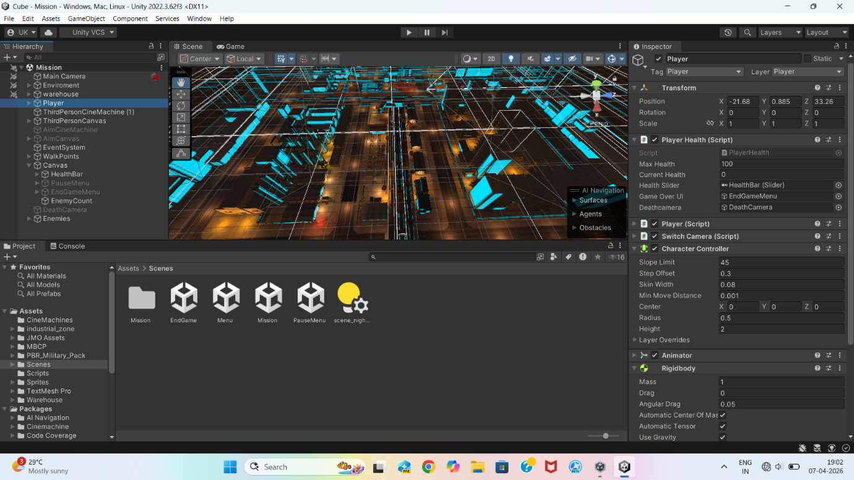

2.3 Functional Requirements
Functional requirements describe what the system should do.
Player Requirements
• Player must move in 3D environment
• Player must shoot enemies
• Player must reload weapon
• Player health must decrease when hit

Enemy Requirements
• Enemies must patrol area
• Enemies must detect player within range
• Enemies must shoot player
• Enemies must play animations

UI Requirements
• Health bar must update in real time
• Enemy counter must display remaining enemies
• Main menu must start the game
• Game over screen must appear when player dies
• Win screen must appear when enemies are eliminated

2.4 Non-Functional Requirements
Performance
Game must run smoothly without lag.
Usability
Game must be simple and intuitive.
Reliability
Game should not crash during gameplay.

2.5 Development Model
The project follows Agile Development Model.
Reasons:
• Continuous testing
• Incremental feature development
• Easy debugging and improvements

CHAPTER 3 :
SYSTEM DESIGN

3.1 Introduction
System design is the phase where the overall architecture of the game is planned before implementation.
In game development, system design defines how different modules such as player control, enemy AI, UI, and game flow interact with each other.
The IGI-3 game follows a modular architecture, where each feature is implemented as an independent script and all modules communicate through Unity components.

3.2 Overall Architecture of the Game
The game architecture consists of four major modules:
- Player Module
- Enemy AI Module
- Combat System
- UI & Game Flow Module
All modules interact through Unity GameObjects and C# scripts.

High Level Architecture Explanation
Input → Player Controller → Shooting System → Enemy AI → Health System → UI → Game Result
This flow ensures real-time interaction between the player and the game world.

3.3 Module Design

3.3.1 Player Module Design 👤
The player module is responsible for controlling the character and interacting with the game world.
Components Used
• Character Controller
• Third-person Camera
• Player Scripts
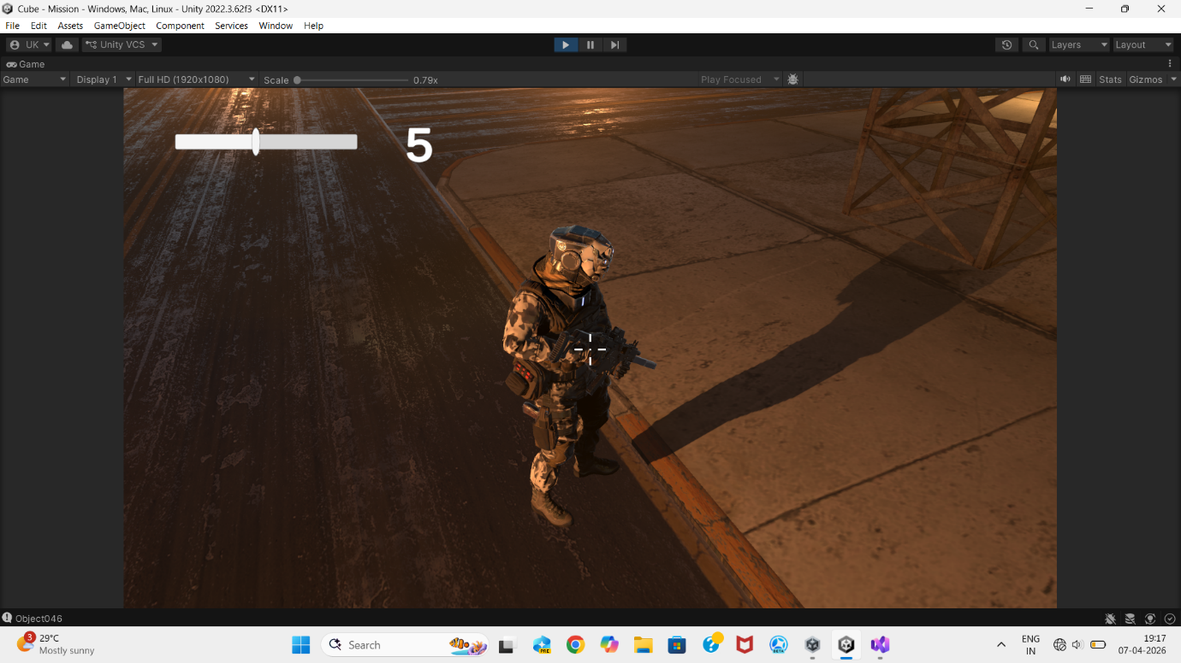

Player Subsystems
1. Movement System
Allows player to:
• Move forward/backward
• Move left/right
• Rotate with mouse

Movement uses:
- CharacterController component
- Input system (WASD keys)
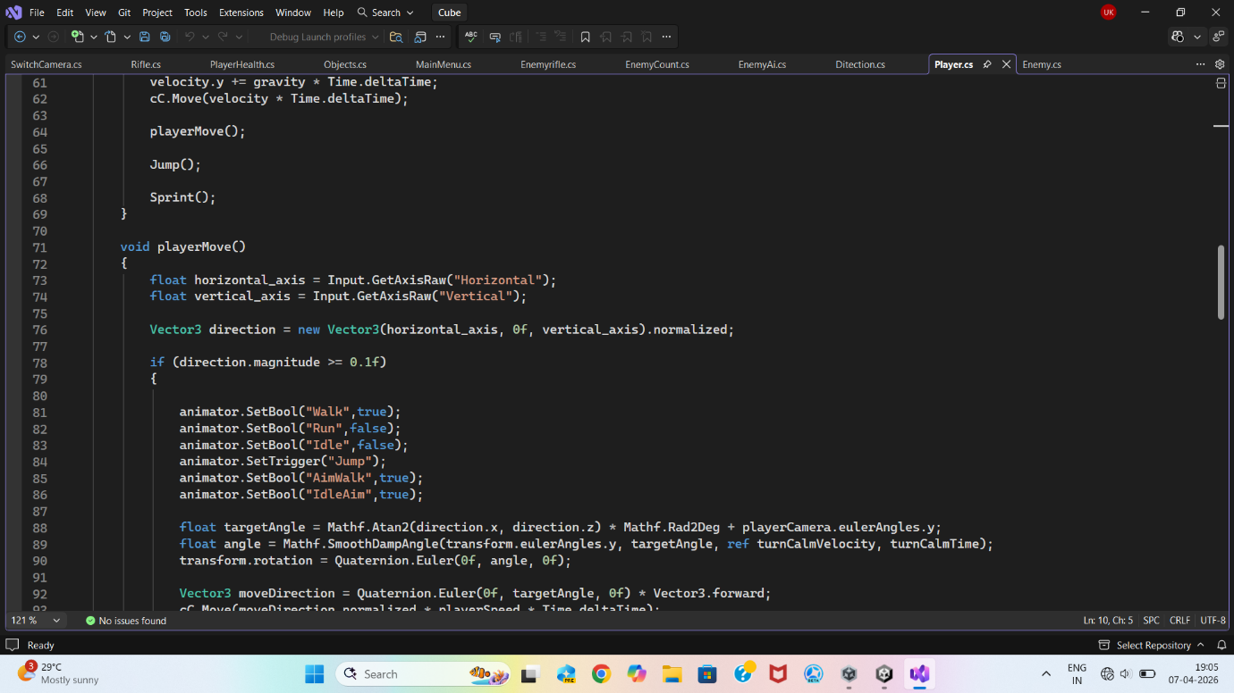

2. Camera Follow System 📷
Third-person camera is positioned behind the player.
Camera behaviour:
• Follows player smoothly
• Rotates with mouse
• Keeps fixed distance
This improves player visibility and situational awareness.

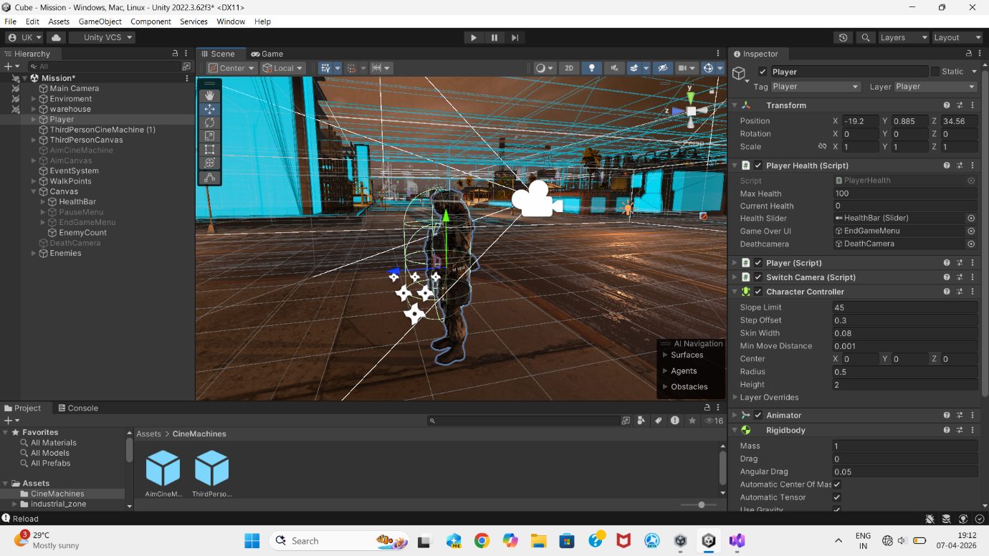

3. Shooting System 🔫
Player weapon system includes:
• Gun firing
• Bullet spawning
• Reload mechanism
Bullet prefab is instantiated and moves forward using physics.

4. Reload System 🔄
Realistic reload mechanism includes:
• Limited magazine capacity
• Reload key press (R)
• Reload delay time
• Shooting disabled during reload
This adds realism and strategy to gameplay.

3.3.2 Enemy AI Module Design 🤖
Enemy AI is the most important system of the game.
Enemies behave using Finite State Machine (FSM).
Enemy States
State | Description
Patrol | Enemy moves between waypoints
Detection | Enemy detects player
Attack | Enemy shoots player
Death | Enemy dies and disappears

1. Patrol System 🟡
Enemy moves between predefined waypoints.
Purpose:
• Simulate guard behaviour
• Make environment feel alive
Implementation:
• Array of walk points
• Random selection of next point
• Continuous movement

2. Player Detection System 👀
Enemy detects player using distance checking.
Detection formula:
Distance = Distance between Enemy and Player
If Distance < Vision Radius → Player detected
Detection radius used: 5 meters
3. Enemy Attack System 🔴
When player is detected:
• Enemy stops patrol
• Enemy rotates toward player
• Enemy shoots bullets
Enemy bullets:
• Move forward
• Detect collision with player
• Reduce player health
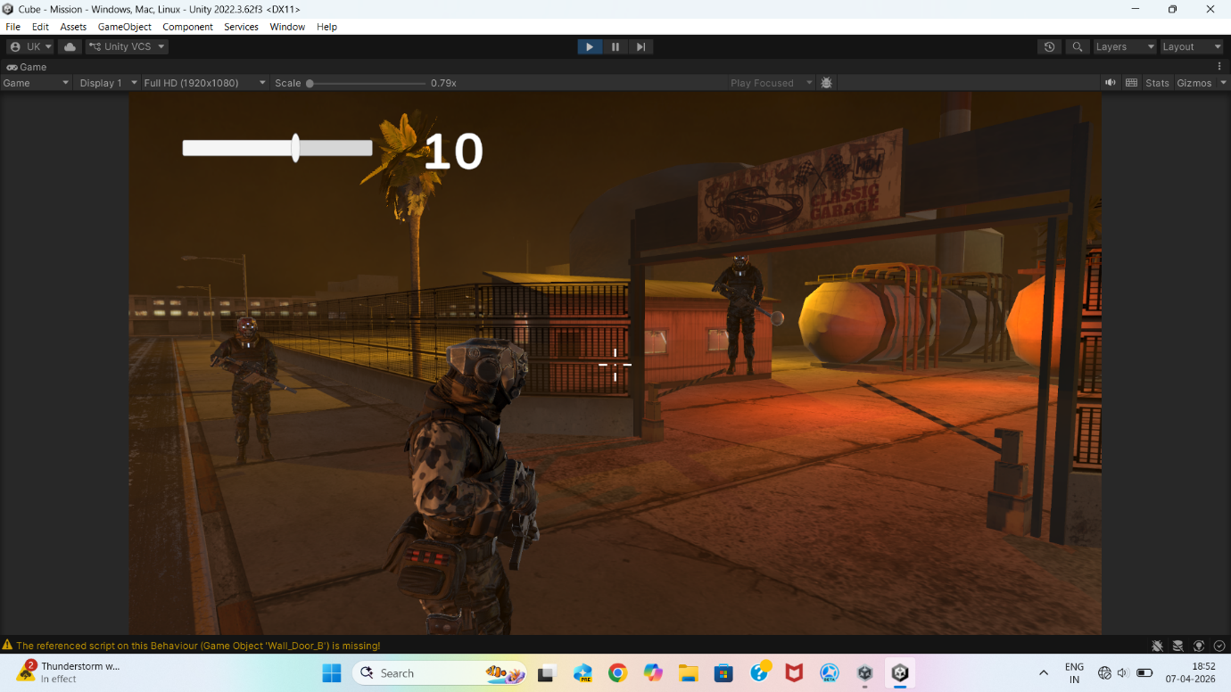

4. Enemy Animation System 🎬
Enemy Animator contains animations:
• Idle
• Walk
• Aim
• Shoot
• Death
Animator transitions change automatically based on enemy state.
This makes enemy behaviour realistic and dynamic.
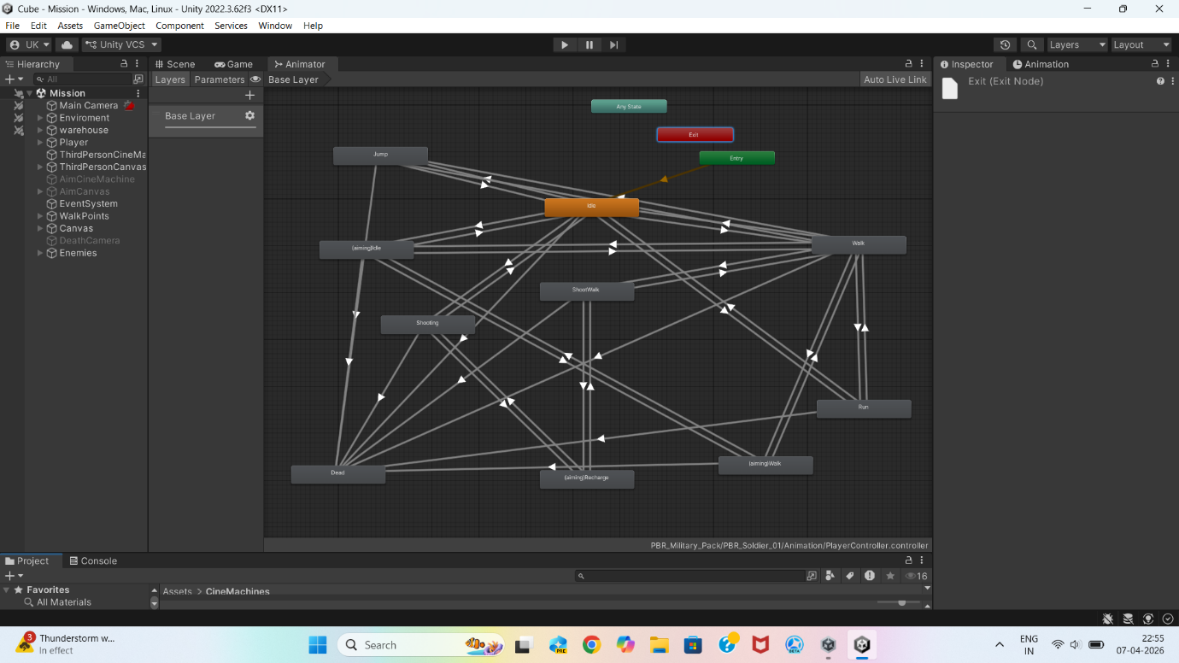

3.3.3 Combat System Design 💥
Combat system connects player and enemy interactions.
Bullet System
Two bullet types exist:
Bullet Type | Target
Player Bullet | Enemy
Enemy Bullet | Player

Collision Detection
Unity Trigger Colliders used.
When collision occurs:
• Health decreases
• If health = 0 → character dies

3.3.4 Health System Design ❤️
Health system maintains life of both player and enemies.
Player Health
• Initial Health = 100
• Enemy bullets reduce health
• Health displayed on slider UI
Enemy Health
• Player bullets reduce health
• Death animation plays
• Enemy destroyed

3.3.5 UI Module Design 🎨
User Interface provides real-time feedback.
UI Elements

UI Element | Purpose
Crosshair | Aim assistance
Health Slider | Player health
Enemy Counter | Remaining enemies
Main Menu | Start game
Game Over Screen | Player death
Win Screen | Mission completed

3.3.6 Game Flow Module 🧭
Controls transitions between game states.
Game States

State | Trigger
Main Menu | Game start
Gameplay | Player playing
Game Over | Player health = 0
Win Screen | Enemy count = 0

3.4 Data Flow Explanation
- Player inputs movement/shooting
- Shooting triggers bullet creation
- Bullet hits enemy → enemy health decreases
- Enemy shoots → player health decreases
- UI updates in real time
- Game ends when win/lose condition met

3.5 Summary
This chapter described the architecture and modules of the IGI-3 TPS game. The modular design ensures easy testing, debugging, and future improvements.

CHAPTER 4 :
IMPLEMENTATION AND TESTING

4.1 Introduction
This chapter explains how the designed system was implemented in Unity and how each module was tested. The implementation phase converts the system design into an actual working game using C# scripts, Unity components, and assets.

4.2 Development Environment
Unity provides an integrated environment that includes physics, animation, lighting, navigation, and UI tools.

Component | Specification
Game Engine | Unity 3D
Programming Language | C#
IDE | Visual Studio
Platform | Windows PC
Graphics | Unity Built-in Render Pipeline

4.3 Scene Creation & Environment Setup
The first step was creating the game environment.
Steps Performed
- Created a new 3D Unity project
- Created ground using Plane object
- Added walls and obstacles using cubes
- Added lighting for visibility
- Created empty GameObjects for enemy waypoints
This formed the playable level.
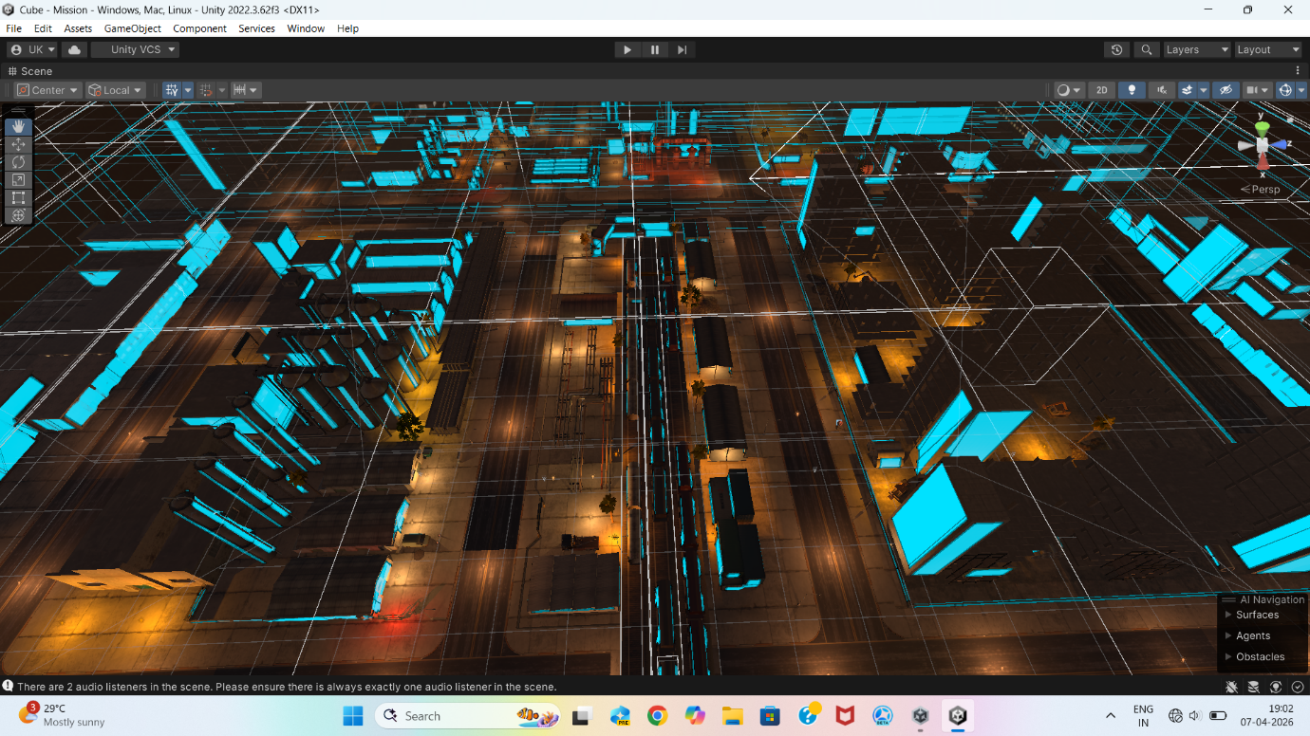

4.4 Player Implementation 👤
4.4.1 Player Movement Script
Player movement was implemented using CharacterController.

Features Implemented
• Forward/backward movement
• Left/right movement
• Mouse rotation
• Smooth motion

Testing
✔ Player moves correctly in all directions
✔ No collision glitches observed

4.4.2 Third-Person Camera Implementation 📷
Camera follows player from behind.
Features
• Smooth follow
• Mouse rotation
• Fixed distance from player

Testing
✔ Camera follows player smoothly
✔ No camera clipping issues

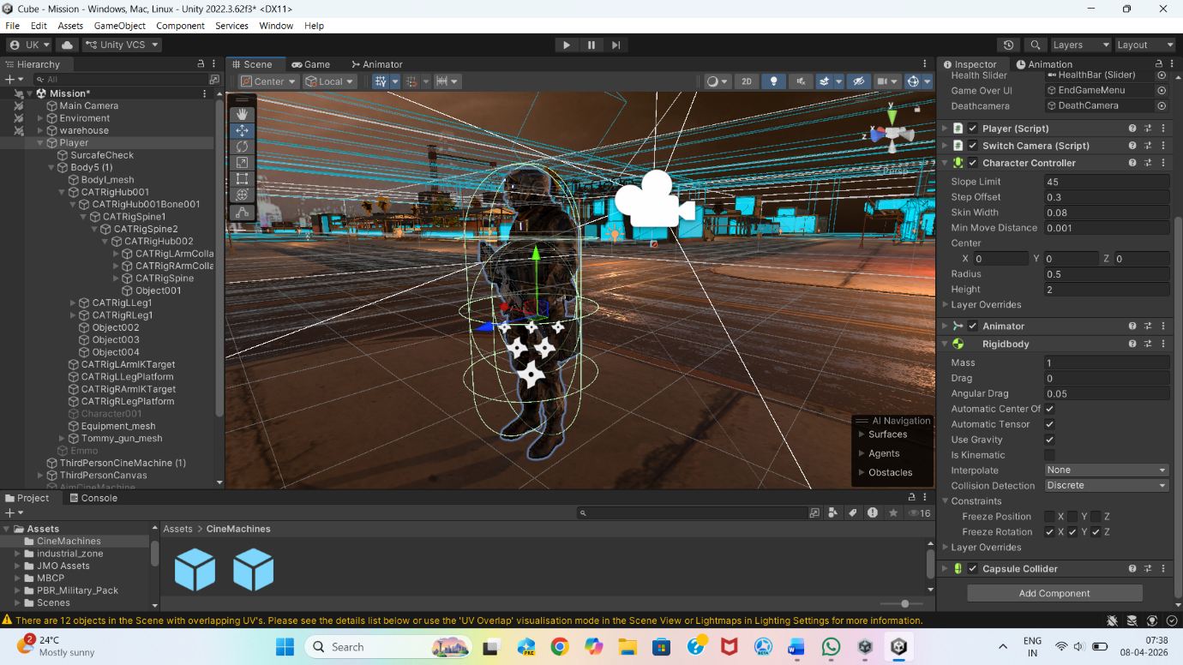

4.5 Shooting & Reload Implementation 🔫
4.5.1 Gun Shooting Script
Implementation Steps
- Created bullet prefab (sphere)
- Added Rigidbody to bullet
- Instantiated bullet when fire button pressed
- Bullet moves forward using velocity

Testing
✔ Bullets spawn correctly
✔ Bullets travel in correct direction

4.5.2 Reload System Implementation
Features
• Limited magazine capacity
• Reload key (R)
• Reload delay timer
• Shooting disabled during reload

Testing
✔ Gun stops firing when ammo empty
✔ Reload works correctly

4.6 Enemy AI Implementation 🤖
4.6.1 NavMesh Setup
NavMesh allows enemies to navigate the environment.
Steps
- Marked ground as Navigation Static
- Baked NavMesh
- Added NavMeshAgent to enemy
Testing
✔ Enemy moves smoothly across map
✔ Avoids obstacles automatically
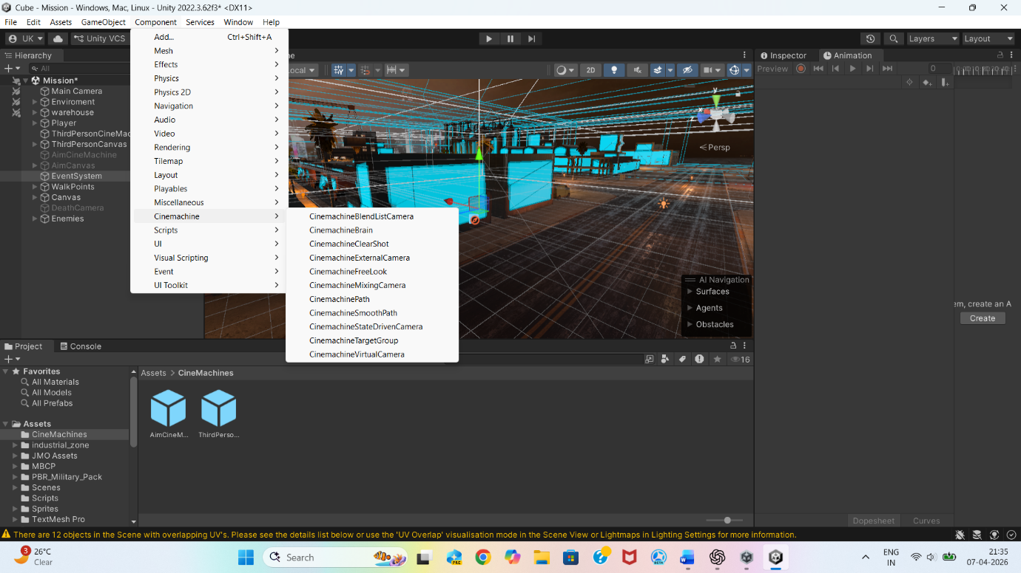

4.6.2 Enemy Patrol Implementation
Enemy patrol script created using waypoint array.
Testing
✔ Enemy moves between points continuously
✔ Patrol behaviour realistic

4.6.3 Player Detection Implementation 👀
Enemy detects player using distance checking.
Testing
✔ Enemy detects player within 5m radius
✔ Enemy ignores player outside range

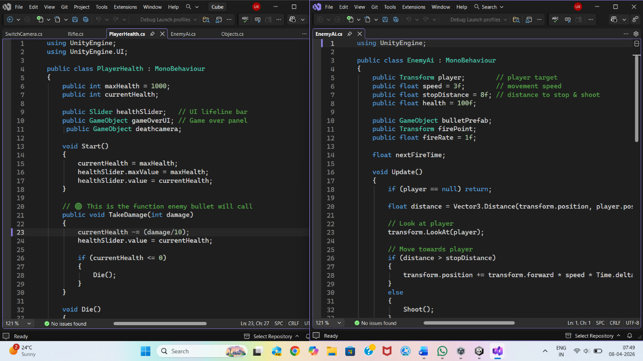

4.6.4 Enemy Shooting Implementation 🔴
Steps
- Enemy faces player
- Instantiates bullet prefab
- Bullet moves toward player
Testing
✔ Enemy shoots only when player detected
4.7 Health System Implementation ❤️
4.7.1 Player Health
• Health variable initialized
• Enemy bullets reduce health
• Health bar updates
Testing
✔ Health decreases correctly
✔ Game Over triggers when health = 0

4.7.2 Enemy Health
• Enemy health decreases when hit
• Death animation plays
• Enemy destroyed
Testing
✔ Enemy removed after death

4.8 UI Implementation 🎨
UI Elements Created
• Crosshair
• Health slider
• Enemy counter text
• Main menu
• Game over screen
• Win screen
Testing
✔ UI updates in real time
✔ Screens appear correctly

4.9 Game Flow Implementation 🧭
Win Condition
Enemy count = 0 → Win screen
Lose Condition
Player health = 0 → Game Over screen
Testing
✔ Both conditions trigger correctly

4.10 Testing Strategy

Testing Type | Purpose
Unit Testing | Individual scripts
Integration Testing | Module interaction
Gameplay Testing | Real gameplay
Debug Testing | Fixing errors

4.11 Summary
All modules were successfully implemented and tested. The game runs smoothly and meets all functional requirements.

CHAPTER 5 :
RESULTS AND DISCUSSION

5.1 Introduction
This chapter presents the final output of the developed game and discusses how the implemented system meets the project objectives. The results demonstrate the successful integration of all modules including player control, enemy AI, combat system, UI and game flow.

5.2 Final Game Overview
The final output is a fully playable Third Person Shooter game where the player can:
• Move freely in the environment
• Shoot enemies using a rifle
• Reload weapon when ammo finishes
• Take damage from enemy bullets
• View health and enemy count in UI
• Win the game by eliminating all enemies
• Lose the game when health reaches zero
This confirms successful implementation of the complete gameplay loop.

5.3 Gameplay Demonstration
Step 1 – Main Menu Screen
When the game starts, the Main Menu appears.
Features:
• Start Game button
• Exit Game button
This provides a professional entry point to the game.
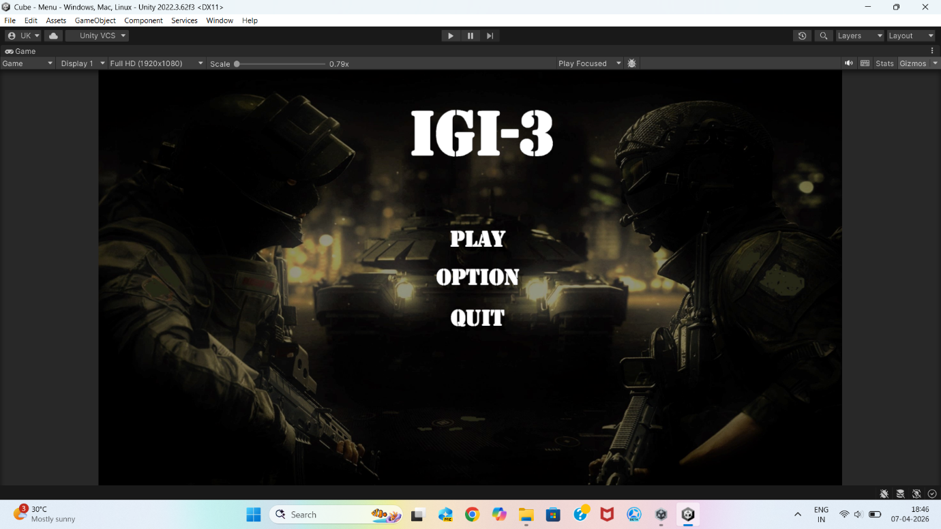

Step 2 – Gameplay Start
After clicking Start Game:
• Player spawns in the environment
• Enemies start patrolling
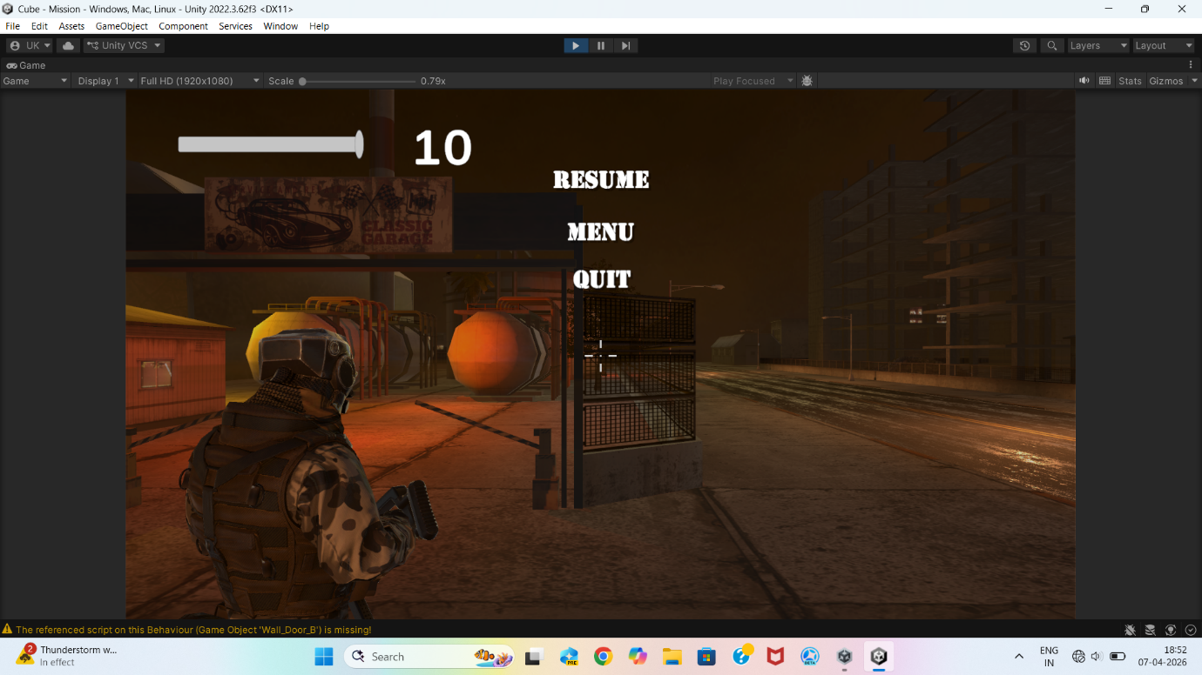
This marks the beginning of gameplay.

Step 3 – Enemy Patrol Behaviour
Enemies move between predefined waypoints.
Observed behaviour:
• Continuous movement
• Realistic guard-like behaviour
• Smooth navigation using NavMesh
This improves immersion and realism.

Step 4 – Player Detection & Combat
When player enters enemy vision range:
• Enemy stops patrolling
• Enemy rotates toward player
• Enemy starts shooting
This demonstrates correct AI state transition.

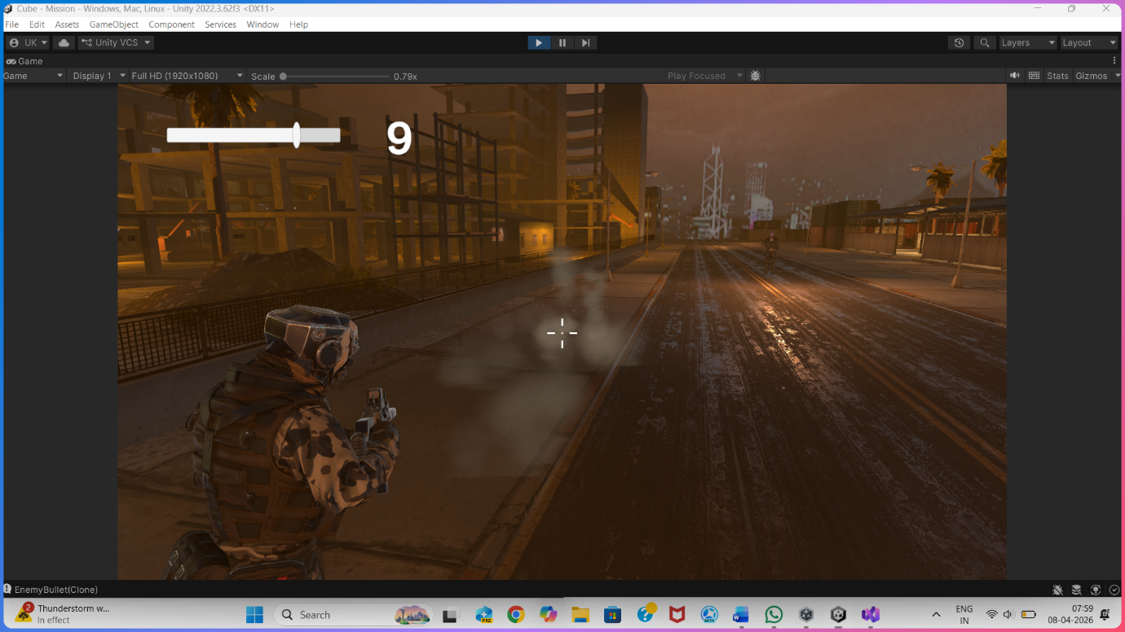

Step 5 – Shooting & Reload System
Player can shoot enemies using rifle.
Observed features:
• Bullets spawn correctly
• Enemy health decreases
• Reload works when ammo finishes
This confirms successful implementation of combat mechanics.

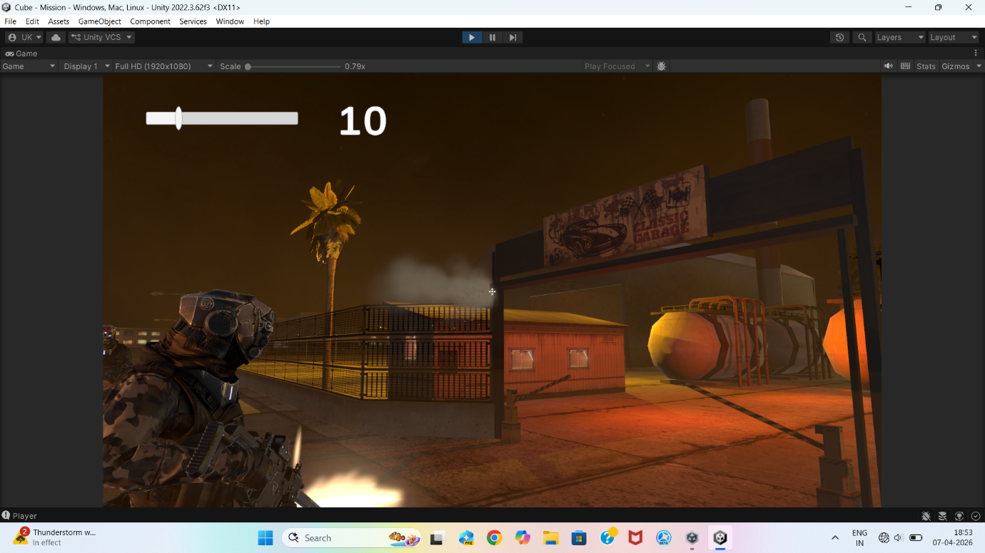

Step 6 – Health System
Player health decreases when hit by enemy bullets.
Observed behaviour:
• Health bar updates in real time
• Game Over screen appears when health reaches zero

Step 7 – Enemy Counter System
UI shows remaining enemies.
Observed behaviour:
• Counter decreases when enemy dies
• Updates in real time
This gives clear mission progress feedback.
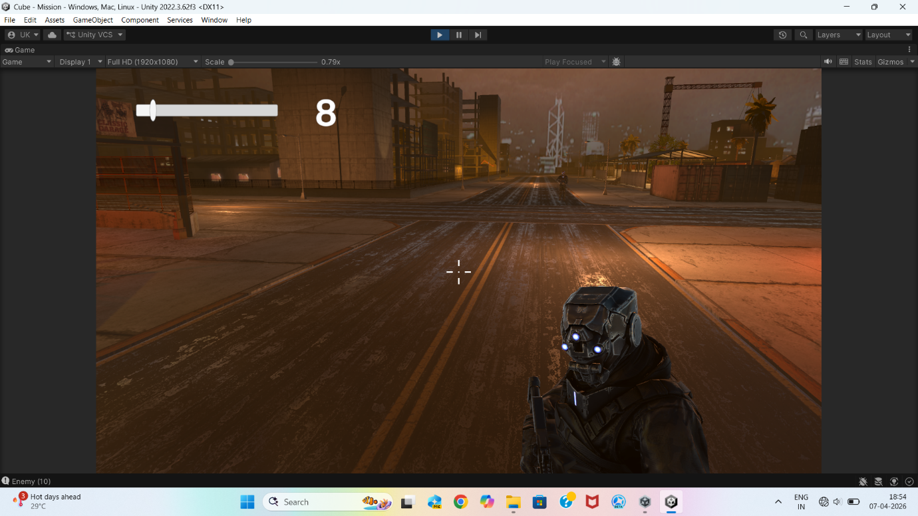

Step 8 – Win Condition
When all enemies are eliminated:
• Enemy counter becomes zero
• Win screen appears
This confirms successful mission completion logic.

5.4 Advantages of the System
• Real-time interactive gameplay
• Easy to expand and modify
• Modular and scalable architecture
• Beginner-friendly implementation
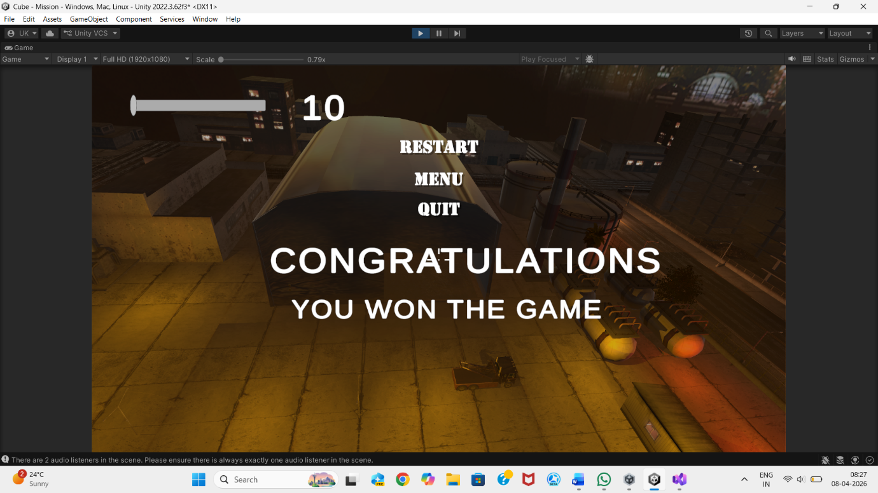

5.5 Results Summary Table
Feature | Result
Player Movement | Successfully implemented
Shooting System | Working correctly
Reload System | Working correctly
Enemy AI | Successfully implemented
Enemy Animations | Working correctly
Health System | Working correctly
Enemy Counter UI | Working correctly
Main Menu | Implemented
Game Over Screen | Implemented
Win Screen | Implemented

5.6 Discussion
The project successfully demonstrates how multiple systems can work together to create a complete game. The modular design helped in easy debugging and testing.

Major Achievements
• Integration of AI with gameplay
• Real-time UI updates
• Smooth player and enemy interaction
• Complete game flow from start to finish

Challenges Faced
• Enemy AI behaviour debugging
• Camera control issues
• Bullet collision detection
• Linking UI with scripts
All challenges were successfully resolved through testing and iteration.

CHAPTER 6 :
CONCLUSION AND FUTURE SCOPE

6.1 Conclusion
The aim of this project was to design and develop a complete Third Person Shooter (TPS) game using Unity and C#. The project successfully achieved all its objectives and demonstrated the practical implementation of game development concepts.
The final game IGI-3 includes all major gameplay systems such as player control, enemy AI, shooting mechanics, animation, UI design, and game flow management. The project provided hands-on experience in integrating multiple modules into a single working application.
Throughout the development process, the project followed a structured software development approach including requirement analysis, system design, implementation, testing, and evaluation.

Project Achievements
The following goals were successfully achieved:
• Developed a third-person player controller
• Implemented realistic shooting and reload system
• Designed enemy AI with patrol, detection and attack behaviour
• Implemented enemy animations and NavMesh navigation
• Created health and damage system
• Designed dynamic user interface
• Implemented main menu, game over and win screens
• Built a complete gameplay loop from start to finish
This confirms that the project meets the requirements of a full game development lifecycle.

6.2 Learning Outcomes
This project provided practical knowledge in the following areas:

Unity Game Development
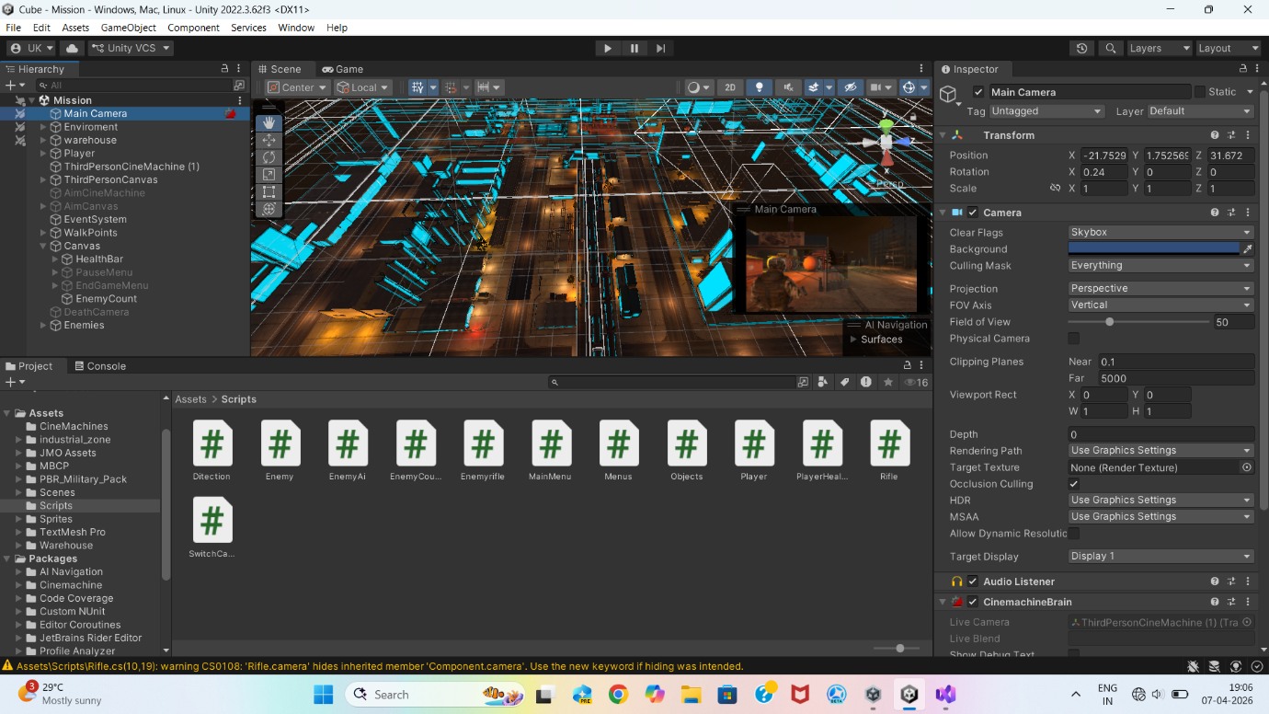
• Scene creation and environment design
• GameObject and component system
• Physics and collision detection
• Navigation and pathfinding

Programming Skills
• Object-oriented programming using C#
• Script communication and modular design
• Debugging and error handling

Game Design Skills
• Gameplay mechanics design
• AI behaviour design
• User interface design
• Game flow management
The project helped in understanding how real games are structured and developed.

6.3 Limitations of the Project
Although the project is fully functional, it has some limitations:
• Single level gameplay
• Basic enemy AI behaviour
• No sound effects or background music
• No multiplayer functionality
• Limited weapon variety
These limitations exist because the main focus was learning the fundamentals of game development.

6.4 Future Scope
The project can be expanded in many ways to create a more advanced and commercial-level game.
Gameplay Improvements
• Add multiple levels and missions
• Add different weapons and power-ups
• Add inventory and upgrade system

AI Improvements
• Advanced enemy pathfinding
• Smarter enemy decision making
• Boss enemy characters

Graphics & Audio Improvements
• Add sound effects and background music
• Improve lighting and environment design
• Add particle effects and explosions

Advanced Features
• Multiplayer mode
• Mobile version of the game
• Save/Load system
These improvements can transform IGI-3 into a complete commercial-quality game.

6.5 Final Summary
IGI-3 successfully demonstrates the development of a 3D Third Person Shooter game using Unity. The project integrates programming, artificial intelligence, animation, physics, and UI into a single working system.
The project proves the understanding of real-world game development and serves as a strong foundation for future advanced game projects.
REFERENCES
• Unity Official Documentation
• Unity Learn Tutorials
• C# Programming Guide
• Game Development Resources

BIBLIOGRAPHY:

https://www.google.com/search?q=chatgpt&oq=ch&gs_lcrp=EgZjaHJvbWUqDggAEEUYJxg7GIAEGIoFMg4IABBFGCcYOxiABBiKBTIGCAEQRRg5MgYIAhBFGDwyBggDEEUYPDIGCAQQBRhAMgYIBRAFGEAyBggGEAUYQDIGCAcQBRhA0gEIMjU2MGowajeoAgCwAgA&sourceid=chrome&ie=UTF-8
https://www.youtube.com/watch?v=IlKaB1etrik
https://www.youtube.com/watch?v=nK_Kdmaq3NI&list=PLA-xaldQ72ry4boMCIL_d0HnliT3FRsSk&index=2&t=14s&pp=0gcJCR0AztywvtLA
https://www.youtube.com/watch?v=nK_Kdmaq3NI&list=PLA-xaldQ72ry4boMCIL_d0HnliT3FRsSk&index=2&t=14s&pp=0gcJCR0AztywvtLA

